Hotfix Automation Scripts

Step1 Find the PowerShell Script from Build updates Ftp://ftpu.prophoenix.com
ftp://buildupdates@ftpu.prophoenix.com/Installation Team/HotfixUpdateScripts/
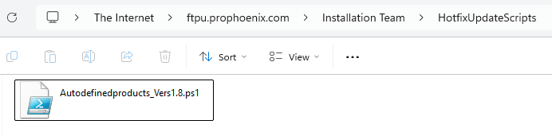

Step2: Download the File in the Local path and verify it is blocked or not in the properties. If Blocked Unblock it
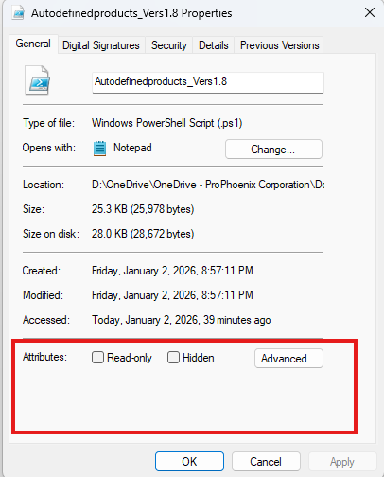
Step3: Windows PowerShell ISE Should be run as Administrator
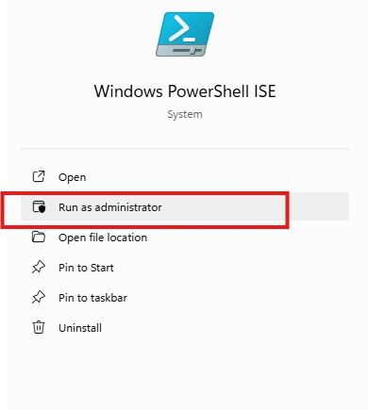
Step4: You can run the PowerShell Script and Find the output of the File path at the end of the result
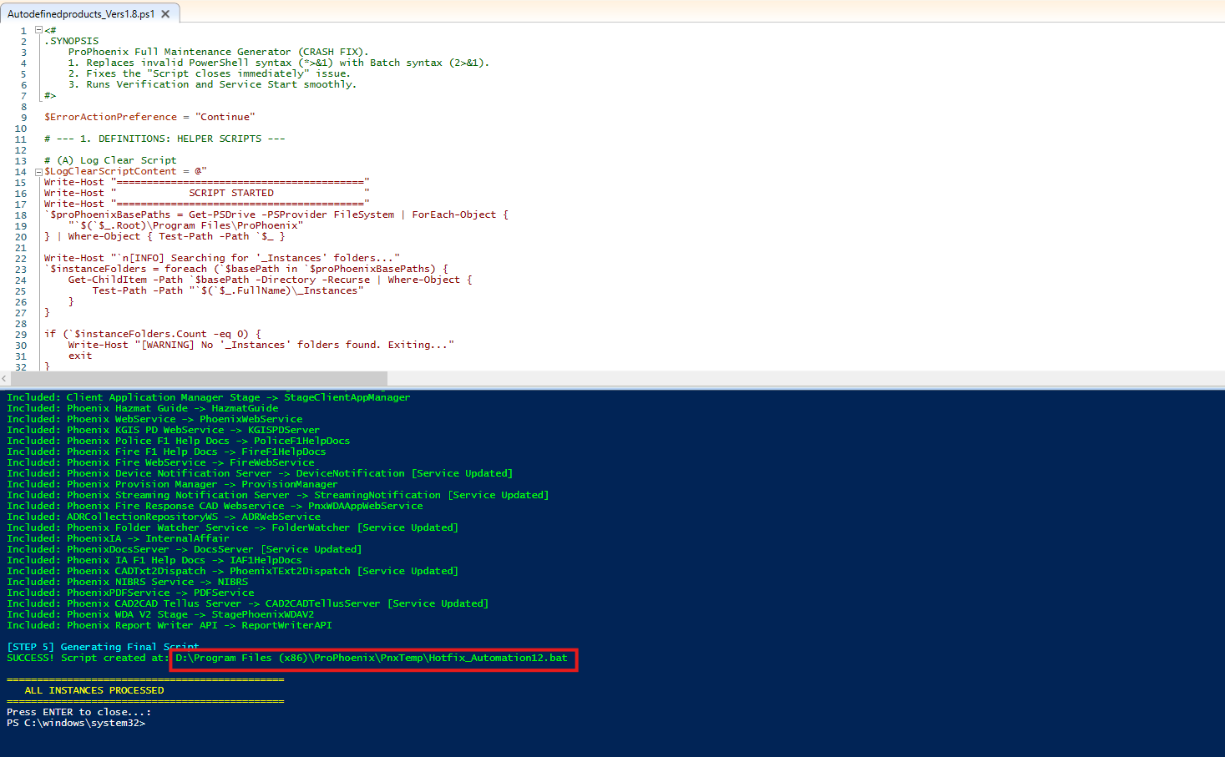

Step5: Find the Hotfix Automation Bat file and Run as Administrator

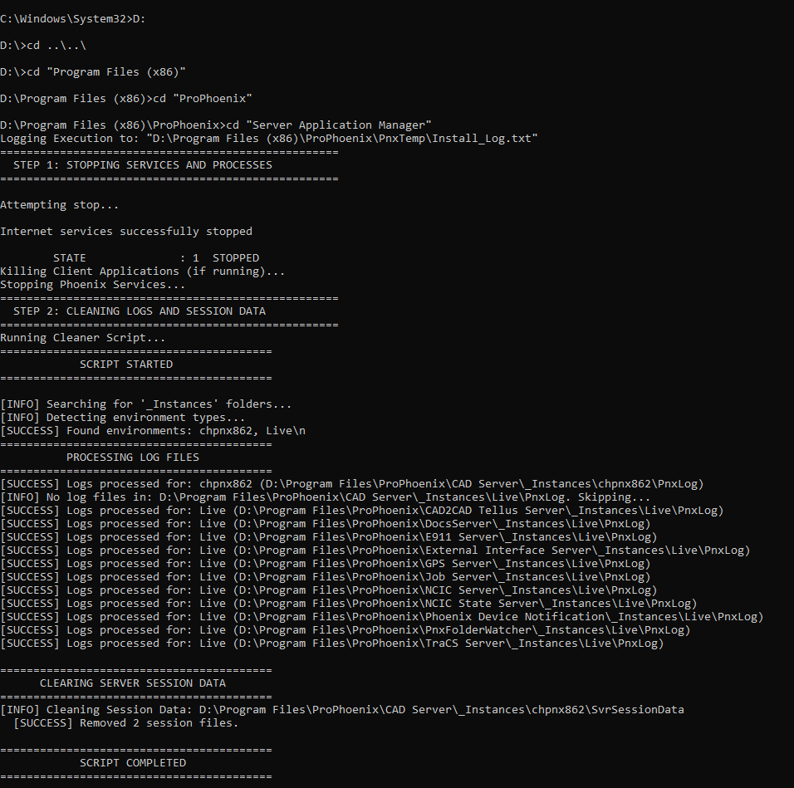
Once Completed You Can Find the Log in the Same Location

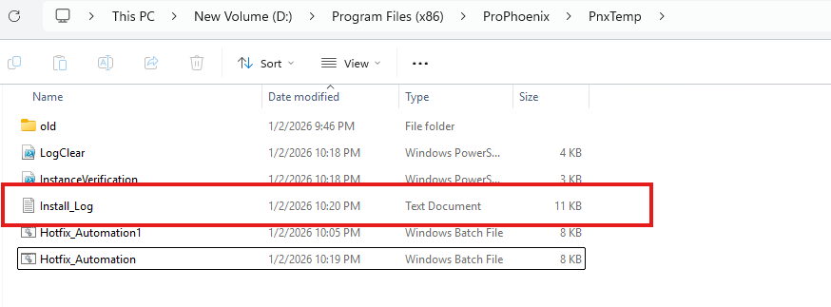
Steps Performed by the Script
- Fetches the products already installed and prepares the BAT file for the hotfix update.
- Executes the BAT file for the hotfix process.
- Identifies the Server Application Manager and runs the log file.
- Stops IIS services.
- Terminates existing client processes from Task Manager.
- Stops Phoenix instance–based services.
- Executes Log Cleaner and clears Server Session data.
- Downloads and installs the application updates.
- Starts IIS services.
- Initiate the instance update.
- Starts Phoenix instance–based services.
- Performs instance update verification.
- Starts the client to initiate the auto-update process.

